|  |
| --- |
| **Mississippi Department oF Revenue** |
| Request for Quote Formal (RFQF)  Reverse Auction 3140001512 |
| Reach Truck Fork Lifts & Stock Pickers |
|  |
| **Procurement Department** |
| **08/01/2018** |

|  |
| --- |
|  |

**MISSISSIPPI DEPARTMENT OF REVENUE**

**Invitation for Bid**

**Stand-Up Forklifts and Stock Pickers**

**GENERAL CONDITIONS – REVERSE AUCTIONS**

**ALL BIDS SUBMITTED SHALL BE IN COMPLIANCE WITH ALL CONDITIONS SET FORTH HEREIN. THE BID PROCEDURES FOLLOWED BY THIS OFFICE WILL BE IN ACCORDANCE WITH THESE CONDITIONS. THEREFORE, ALL BIDDERS ARE URGED TO READ AND UNDERSTAND THESE CONDITIONS PRIOR TO SUBMITTING A BID.**

**1. DEFINITIONS**

The use of the word “agency” in any Bid Invitation solicitation or specification shall be intended to mean state agencies only. The words “governing authority” when used shall be intended as meaning city, county or other local entities.

**2. PREPARATION OF BIDS**

2.1 Bids and/or Quotes may be submitted through the State of Mississippi’s e-procurement system (MAGIC) or in person to the Mississippi Department of Revenue (“DOR” or “the Department”). Paper bids are allowed. All prices and notations must be printed in ink or typewritten. No erasures permitted. Errors may be crossed out and corrections printed in ink or typewritten adjacent and must be initialed, in ink, by the person signing bid.

2.2 To submit bids electronically, bidders must ensure they are registered in the MAGIC system and have received a login, password, and supplier number and that all technical requirements have been met.

2.3 If a bidder is unwilling or unable to participate through MAGIC, an DOR representative can enter the Vendor’s bid(s) manually (i.e. Surrogate bidding).

2.4 Bidders participating in person by surrogate bidding must so indicate in their response to the initial Request for Quote-Formal (RFQF).

2.5 Failure to examine any drawings, specifications, and instructions will be at bidder's risk.

2.6 Price each item separately. Unit prices shall be shown. Bid prices must be net.

2.7 It is understood that reference to available specifications shall be sufficient to make the terms of such specifications binding on the bidder.

2.8 Bidders must furnish all information requested in the bid specifications. Further, when required, each bidder must submit for bid evaluation cuts, sketches, descriptive literature and technical specifications covering the product offered. Reference to literature submitted with a previous bid or on file with DOR will not satisfy this provision.

2.9 Samples of items, when requested, must be furnished free of expense, and if not destroyed in testing will, upon request, be returned at the bidder's expense. Request for the return of samples must be made within ten (10) days following opening bids. Each individual sample must be labeled with bidder's name, manufacturer's brand name and number, State of Mississippi commodity number, bid number and item reference.

2.10 Time of performance. The number of calendar days in which delivery will be made after receipt of order shall be indicated in the bid specifications.

**3. BID SUBMISSION**

3.1 When submitting a bid electronically, the authorized signature may be typed or be an electronic signature.

3.2 Bids and modifications or corrections received after the closing time specified will not be considered.

3.3 When submitting the response to the RFQF in MAGIC, bidder must ensure all questions have been answered within the RFQF and all proposed items in bid have a response.

3.4 Bidders submitting paper responses should submit responses to the DOR by the response deadline.

**4. ACCEPTANCE OF BIDS**

DOR reserves the right to reject any and all bids, to waive any informality in bids and unless otherwise specified by the bidders, to accept any items on the bid. The State reserves the right to modify or cancel in whole or in part its Invitation for Bids.

If a bidder fails to state the time within which a submitted will expire, it is understood and agreed that DOR shall have 60 days to accept.

**5. ERROR IN BID**

If a vendor is participating in a Live Auction, the vendor can notify DOR in the event of an erroneous bid via the chat message feature. Erroneous bids, where the mistake is apparent to DOR, may be deleted during the live auction.

**6. SPECIAL DISCOUNT PERIOD**

Time in connection with a special discount offered will be computed from date of delivery at destination or from the date correct invoices are received, if the latter date is later than the date of delivery. Cash discounts will not be considered in the award process.

**7. AWARD**

7.1 Contracts and purchases will be made or entered into with the lowest responsible bidder meeting specifications, except as otherwise specified in the bid specifications. Where more than one item is specified in the specifications, the State reserves the right to determine the low bidder either on the basis of the individual item(s) or on the basis of all items included in its Invitation for Bids, or as expressly provided in the State's Invitation for Bids.

7.2 A written purchase order or contract award furnished to the successful bidder within the time of acceptance specified in the Invitation for Bid results in a binding contract without further action by either party. The contract shall consist solely of these General Conditions, the Instructions and Special Conditions, the successful bidder’s bid, and the written purchase order or contract award. The contract shall not be assignable in whole or in part without the written consent of the State.

**8. INSPECTION**

Final inspection and acceptance or rejection may be made at delivery destination, but all materials and workmanship shall be subject to inspection and test at all times and places, and when practicable. During manufacture, the right is reserved to reject articles which contain defective material and workmanship. Rejected material shall be removed by and at the expense of the contractor promptly after notification or rejection. Final inspection and acceptance or rejection of the materials or supplies shall be made as promptly as practicable, but failure to inspect and accept or reject materials or supplies shall not impose liability on the State or any subdivision thereof for such materials or supplies as are not in accordance with the specification. In the event necessity requires the use of materials or supplies not conforming to the specification, payment therefore may be made at a proper reduction in price.

**9. TAXES**

The State is exempt from federal excise taxes and state and local sales or use taxes and bidders must quote prices which do not include such taxes. Exemption certificates will be furnished upon request. Contractors making improvements to, additions to or repair work on real property on behalf of the State are liable for any applicable sales or use tax on purchase of tangible personal property for use in connection with the contracts. Contractors are likewise liable for any applicable use tax on tangible personal property furnished to them by the State for use in connection with their contracts.

**10. GIFTS, REBATE, GRATUITIES**

10.1 Acceptance of gifts from bidders is prohibited. No officer or employee of DOR, nor any head of any state department, institution or agency, nor any employee of any state department, institution or agency charged with responsibility of initiating requisitions, shall accept or receive, directly or indirectly, from any person, firm or corporation to whom any contract for the purchase of materials, supplies, or equipment for the State of Mississippi may be awarded, by rebate, gifts, or otherwise, any money or anything of value whatsoever, or any promise, obligation or contract for future rewards or compensation.

10.2 Bidding by state employees is prohibited. It is unlawful for any state official or employee to bid on, or sell, or offer for sale, any merchandise equipment or material, or similar commodity to the State during the tenure of his or her office or employment, or for the period prescribed by law thereafter, or to have any interest in the selling of the same to the State.

**11. BID INFORMATION**

Bid information and documents may be examined pursuant to the Mississippi Public Records Act of 1983, MS Code 25-61-1 et seq.

**12. PRECEDENCE**

Bids shall be made and the contract shall be entered into in accordance with the General Conditions as hereinafter amended and modified. Should a conflict exist between the General Conditions and the Instructions and Special Conditions, the Instructions and Special Conditions shall take precedence.

**13. COMPETITION**

There are no federal or state laws that prohibit bidders from submitting a bid lower than a price or bid given to the U.S. Government. Bidders may bid lower than U.S. Government contract price without any liability as the State is exempt from the provisions of the Robinson-Patman Act and other related laws. In addition, the U.S. Government has no provisions in any of its purchasing arrangements with bidders whereby a lower price to the State must automatically be given to the U.S. Government.

**14. WAIVER**

DOR reserves the right to waive any General Condition, Special Condition, or minor specification deviation when considered to be in the best interest of the State.

**15. CANCELLATION**

Any contract or item award may be canceled with or without cause by the State with the giving of 30 days written notice of intent to cancel. Cause for the State to cancel may include, but is not limited to, cost exceeding current market prices for comparable purchases; request for increase in prices during the period of the contract; or failure to perform to contract conditions. The Contractor will be required to honor all purchase orders that were prepared and dated prior to the date of expiration or cancellation if received by the Contractor within a period of 30 days following the date of expiration or cancellation. Cancellation by the State does not relieve the Contractor of any liability arising out of a default or nonperformance. If a contract is canceled by the State due to a Contractor’s request for increase in prices or failure to perform, that Contractor will be disqualified from bidding for a period of 24 months. The Contractor may cancel a contract for cause with the giving of 30 days written notice of intent to cancel. Cause for the Contractor to cancel may include, but is not limited to the item(s) being discontinued and/or unavailable from the manufacturer.

**16. SUBSTITUTIONS DURING CONTRACT**

During the term of a contract, if adequate documentation is provided that supports the claim that the contract item(s) are not available, items which meet the minimum specifications may be substituted if approved by DOR and the substitutions are deemed to be in the best interest of the State.

**17. APPLICATION**

It is understood and agreed by the bidder that any contract entered into as a result of this Invitation for Bids is established for use by state agencies and all purchases made by these agencies for products included under the provisions of the contract shall be purchased from the bidder receiving the award unless exempt by special authorization from the DOR.

Under the provisions of Section 31-7-7 Mississippi Code of 1972, Annotated, the prices offered herein shall be extended to the governing authorities. However, the governing authorities, by provisions of Section 31-7-12 Mississippi Code, may purchase products covered by state contracts from any source offering an identical product at a price that does not exceed the state contract price.

Employees of DOR have acted exclusively as agents of the State for the award, consummation, and administration of the contract and are not liable for any performance or nonperformance by the state agencies that utilize the contract.

**18. ADDENDA**

Addenda modifying plans and/or specifications may be issued if time permits. No addendum will be issued within a period of two (2) working days prior to the time and date set for the bid opening. Should it become necessary to issue an addendum within the two (2) day period prior to the bid opening, the bid date will be reset to a date not less than five (5) working days after the date of the addendum, giving bidders ample time to comply with the addendum. When replying to a bid request on which an addendum has been issued, and the specifications require acknowledgement, the bid shall indicate that provisions of the addendum have been noted and that the bid is being offered in compliance therewith. Failure to make this statement may result in the bid being rejected as not being in accordance with the revised specifications or plans.

**19. NONRESPONSIVE BIDS**

Nonresponsive bids will not be considered. A non-responsive bid is considered to be a bid that does not comply with the minimum provisions of the specification. Any bidder found to repeatedly offer alternated products that are not compliant with specifications in an attempt to obtain a contract on the basis of pricing only will be disqualified from bidding for a period of 24 months.

**20. SPECIFICATION CLARIFICATION**

It shall be incumbent upon all bidders to understand the provisions of the specifications and to obtain clarification prior to the time and date set for the live auction or bid opening. Such clarification will be answered only in response to a written request submitted in the specified amount of time set by DOR. DOR reserves the right to specify a time frame in which clarification request shall be made.

**21. PRE-QUALIFICATION PROCESS**

22.1 The purpose of the RFQF is to advertise the competitive procurement for solicitation of formal quotes from potential bidders to participate in the Reverse Auction. DOR will be responsible for defining product categories, adding bidders, and publishing all bid related documents to the procurement portal. Once the responses have been received and the Opening Date has been reached, DOR will review the submissions to qualify bidders and determine a starting price for reverse auction items.

22.2 The Invitation for Bids/RFQF shall be advertised in accordance with Section 3.106.05.4 of the Mississippi Procurement Manual. The OPTFM shall advertise for 14 consecutive days in accordance with Section 31-7-13(c)(i)(1) of the Miss. Code Ann. Responses to the RFQF will be due on the 8th working day after the last day of advertisement.

22.3 Responses to the RFQF will be reviewed by the DOR for responsiveness to specifications. Price quotes received will be evaluated in conjunction with other market research to determine the starting price for the Auction.

22.4 DOR will accept bidder responses in MAGIC who have qualified meeting RFx specifications. Bidders not meeting specifications will not be allowed to participate in the Auction.

22.5 Once qualified, DOR will notify the vendor of Qualification and the date of the Live Auction via email. After receiving the confirmation email, bidders should review/ensure technical requirements for MAGIC have been met or confirm participation in person.

22.6 It is requested that bids be submitted on the basis of statewide distribution. Contractors must maintain adequate distribution capabilities and adequate stock of all items to insure prompt delivery.

**23. FIRM BID PRICE**

Prices accepted from bidder submissions shall be firm for the term of the contract except that the State shall receive the benefit of any price decrease in excess of five (5) percent. The contractor must provide written price reduction information within ten (10) days of its effective date.

**24. CONTRACT EXTENSION**

24.1 Automatic contract renewals or extensions are not allowed. Contracts must be extended or renewed with the proper documents signed or approved by DOR.

24.2 DOR reserves the right to extend the term of a contract, when necessary, to continue a source of supply whenever new or replacement contracts are not completed prior to the expiration date. Such extensions are dependent upon the agreement of the Contractor and shall not exceed three (3) months.

**25. SUSPENSION AND DEBARMENT**

By submitting a bid, the bidder is certifying that neither the bidder nor any potential subcontractors are debarred or suspended or are otherwise excluded from or ineligible for participation in federal assistance programs.

**26. ASSIGNMENT**

The Contractor shall not assign or subcontract in whole or in part, its right or obligations under this agreement without prior written consent of DOR.

**27. INDEMNIFICATION**

Contractor shall indemnify, defend, save and hold harmless, protect, and exonerate the State of Mississippi, its Commissioners, Board Members, officers, employees, agents, and representatives from and against all claims, demands, liabilities, suits, actions, damages, losses, and costs of every kind and nature whatsoever, including, without limitation, court costs, investigative fees and expenses, and attorneys’ fees, arising out of or caused by Contractor’s and/or its partners, principals, agents, employees, and/or subcontractors in the performance of or failure to perform this Agreement. In the State’s sole discretion, Contractor may be allowed to control the defense of any such claim, suit, etc. In the event Contractor defends said claim, suit, etc., Contractor shall use legal counsel acceptable to the State; Contractor shall be solely liable for all reasonable costs and/or expenses associated with such defense and the State shall be entitled to participate in said defense. Contractor shall not settle any claim, suit, etc., without the State’s concurrence, which the State shall not unreasonably withhold.

**28. LIVE AUCTION**

28.1 Notification of Auction Start date and time will be sent via email to qualifying bidders. If a bidder is unwilling or unable to participate through MAGIC, a representative from DOR can enter the Vendor’s bid(s) manually (i.e. Surrogate Bidding). If a bidder elects to participate via Surrogate Bidding, the bidder must be physically present at the public bidding location, with the means to submit written bids for each offer made and signed by an authorized agent of the Vendor. A Bid Form will be provided to the Vendor at the start of the auction. This form will not be returned to the bidder but will become a part of the Bid Documentation for Evaluation by DOR.

28.2 The Auction time may be extended at the discretion of the DOR. Examples of reasons to extend an auction include, but are not limited to, technical difficulties experienced by DOR or bidder, the need to pause the Auction, or bids placed within the last few moments of bidding.

28.3 Communication with bidders participating electronically during the Auction may be done via the Live Chat Feature. DOR has the ability to send messages to particular bidders or broadcast to all bidders. Bidders can ONLY communicate with DOR, not other bidders.

28.4 Bidders may be removed from a Live Auction for improper conduct, including but not limited to profanity, threats, consistently entering erroneous or extremely low bids, or other disruptive behavior.

**29. FORCE MAJEURE**

If DOR is closed for any reason, including but not limited to: acts of God, strikes, lockouts, riots, acts of war, epidemics, governmental regulations superimposed after the fact, fire, earthquakes, floods, or other natural disasters (the “Force Majeure Events”), which closure prevents the opening of bids at the advertised date and time, all bids received shall be publicly opened and read aloud on the next business day that the agency shall be open and at the previously advertised time. The new date and time of the bid opening, as determined in accordance with this paragraph, shall not be advertised, and all bidders, upon submission of a bid proposal, shall be deemed to have knowledge of and shall have agreed to the provisions of this paragraph. Bids shall be received by the agency until the new date and time of the bid opening as set forth herein. DOR shall not be held responsible for the receipt of any bids for which the delivery was attempted and failed due to the closure of DOR as a result of a Force Majeure Event. Each bidder shall be required to ensure the delivery and receipt of its bid by DOR prior to the new date and time of the live auction or bid opening.

**Section II**

**Instructions and Special Conditions**

1. **Purpose:**

The Department of Revenue (referred to as “DOR” or “Department”) is seeking to obtain forklifts and stock pickers that are best suited to the intended use at our Liquor Distribution Center. The rental of this equipment will enhance the productivity of delivery of product to the trucks for delivery.

It is the responsibility of the prospective bidder to review all information contained within this Invitation and accompanying attachments. Notifications must be sent to the Department of Revenue if a vendor believes the information contained in this Invitation is devised in such a manner that would restrict competition. The Purchasing Division may be reached at telephone number (601) 923-7680 or facsimile number (601) 923-7681.

1. **Procurement Time Line**

It is our intent to follow the schedule below in the execution of this invitation for bid; however, DOR reserves the right to amend and/or change the below schedule of events, as it deems necessary.

1. **Invitation for Bid Issue Date:** August 17, 2018
2. **First Publication** **:** August 17, 2018
3. **Second Publication:**  August 24, 2018
4. **Deadline for Submission of Questions:** August 29, 2018, 12:00 noon (CST)
5. **Bid Packet Submission Deadline:** September 5 , 2018, 12:00 noon (CST)
6. **Evaluation:**  September 6, 2018
7. **Qualify Proposals:**  September 6, 2018
8. **Email Qualified Bidders:** September 10, 2018
9. **Protest Deadline:** September 17, 2018, 12 noon (CST)
10. **Reverse Auction Start Date:** September 25, 2018, 2:00 pm (CST)
11. **Bid Evaluations:**  September 26, 2018
12. **Projected Award:** September 28, 2018
13. **Submission to PPRB:** October 1, 2018
14. **PPRB Meeting:** November 7, 2018
15. **Projected Start:** January 1, 2019

**3.0 General Terms of Contract**

The term of the contract shall be from January 1, 2019, through December 31, 2020. This contract is for a two (2) year period.

**4.0 References**

As part of its bid, each prospective provider must furnish contact information for at least four current references for purchases with their largest clients of similar size and scope of services as specified in this IFB. “Largest client” is determined by the revenue paid by the client to the provider over the past two year period. Failure to list a qualifying client may result in rejection of prospective provider’s bid. DOR will contact these clients as references to evaluate the quality of the Purchased equipment. Reference information must be provided, as part of the bid package submitted for consideration. References must report the vendor to be of good reputation in providing applicable products. Although DOR requires the provision of a minimum of four references, bidder may submit as many references as desired. References will be contracted in order listed until three references have been interviewed. No further references will be contacted; however, bidders are encouraged to submit additional references to ensure that at least three references are available for interview. The DOR staff must be able to contact three references for a bidder to be found responsible.

**5.0 Business Longevity**

Each provider must have been in business a minimum of four (4) years prior to submission of its bid. Please indicate the length of time you have been in business providing equipment as specified in this IFB. Business longevity information must be provided, as part of the bid package submitted for consideration.

**6.0 Approach**

It is understood that all bids are submitted on the basis of complying with the provisions, terms and specifications set out herein, provided that you can do so under the various government rulings and directives now in effect or which may be issued during the period of the contract. The Department reserves the right to waive minor technicalities on bid forms and specifications that can be waived or corrected without prejudice to other bidders when it is in the best interest of the Department of Revenue. The Department reserves the right to reject any and all bids, to waive any minor informality in the bids, and, unless otherwise specified by the bidders, to accept any items on the bid.

**7.0 Scope of Service**

The specifications set forth herein as “Attachment A” and “Attachment B” represent a minimum of required equipment and operational needs of DOR. The bidder may propose options above and beyond these specifications that best suit DOR’s interest as determined by the agency. The bidder agrees to begin delivery within **60 days** of award. Failure to do so may result in cancellation of award. If cancellation of award occurs, a new award will be made to the next lowest bidder meeting required specifications. Please respond “Yes” or “No” to indicate compliance to the specifications for each listed criterion and add comments as needed.

**8.0 Procurement Methodology**

**8.1 Rules of Procurement**

All formal bids shall be binding for a minimum of forty-five (45) days after opening.

**8.2 Procedure for Answering Questions**

1. All questions concerning this Invitation for Bid or quote process must be submitted by email to:

[BidQuestions@dor.ms.gov](http://www.dor.ms.gov)

1. Questions and request for clarification must be submitted via email during normal business hours by the deadline reflected in Section 2.0, Procurement Time Line
2. All questions and answers will be answered and published on the Mississippi Department of Revenue website ([www.dor.ms.gov](http://uperform.magic.ms.gov/gm/folder-1.11.7512)) under the Publications tab in a manner that all bidders will be able to view by the date and time reflected in Section 2.0.
3. The DOR will not be bound by any verbal or written information that is not contained within this IFB unless formally noticed and issued by the contact person.

**8.3 Bid Amendment or Withdrawal**

No bids shall be altered or amended after the specified time for opening bids. If a bid is withdrawn after opening, the bidder will be removed from the list of eligible bidders for a period of six (6) months.

**8.4 Amendments to the Invitation for Bid**

The Purchasing Division of the Department of Revenue will prepare a written notification of all amendments to the IFB and forward a copy of it to all persons/companies that have requested a copy of the Invitation for Bid. Each vendor shall acknowledge receipt of amendments by completing and signing the Acknowledgement of Amendments form included in this IFB. The Purchasing Division of DOR will also post the Amendment by number on the DOR website [www.dor.ms.gov](http://www.dor.ms.gov) under the Publication tab in a manner all bidders will be able to view. Respondents shall rely only on this bid and any communication from the Purchasing Division of the Department of Revenue in submitting bids. The Department of Revenue’s Purchasing Division shall not be bound by any oral communications; bidders who rely upon any oral communications regarding the IFB do so at their own risk.

**8.5 Bid Acceptance Period**

The original bid form, cover sheet, certification to sign form, references and all acknowledgement forms, shall be signed and submitted in a sealed envelope or packet to the address noted in Section II 9.3 Bid Labeling and Mailing address, no later than the time specified by the Procurement timeline. Timely submission of the bid forms is the responsibility of the bidder. Bids received after the specified time shall be rejected and returned to the bidder unopened. The envelope or packet shall be marked with the bid opening date and time, and the number of the invitation for bid. The time and date of receipt shall be indicated on the envelope or packet by purchasing personnel or Support Staff. Each page of the bid and all attachments shall be identified with the name of the bidder. Failure to submit a bid on the bid form shall be considered just cause for rejection of the bid. Modifications or additions to any portion of the procurement document may be cause for rejection of the bid. DOR reserves the right to decide, on a case-by-case basis, whether to reject a bid with modifications or additions as non-responsive. As precondition to bid acceptance, DOR may request the bidder to withdraw or modify those portions of the bid deemed non-responsive that do not affect quality, quantity, price or delivery of service.

**8.6 Bid Evaluation**

Contracts and purchases will be made or entered into with the lowest, responsible and responsive bidder meeting specifications. Factors to be considered in determining the lowest, responsible bidder include:

* Price
* Conformity
* Responsibility of Bidder
* Bidder’s ability to deliver as per specifications
* Reference response
* Qualified to contract with the State of Mississippi

**8.7 Award Notice**

Suppliers should be advised no award will automatically result from a reverse auction. DOR will review the results of the auction and make a determination. After the Department of Revenue makes the award, official notification will be sent to all participating vendors. This information will be released in written form via email and/or letter. The Department of Revenue will not respond to telephone calls requesting the information. Actions taken by a bidder before the receipt of the official notification will be at the bidder’s own risk, and the Department of Revenue will not be responsible for such actions. If the purchase is for an amount greater than $50,000, such award shall be subject to approval of the purchase/rental by the Department of Finance and Administration.

**8.8 Right to Protest**

Any actual or prospective bidder, offeror, or contractor who is aggrieved in connection with the solicitation or award of a contract may protest to the Director of Purchasing or the Commissioner of the Mississippi Department of Revenue. The protest shall be submitted in writing within seven (7) days after notification is received. The written protest letter shall contain an explanation of the basis of the protest. A protest is considered submitted when received by the Director of Purchasing or Commissioner of the Mississippi Department of Revenue. To expedite handling the protest, the envelope should be labeled “Protest”. Protest filed after normal business hours on the seventh day will not be considered.

**8.9 Partial Bids Prohibited**

Bids submitted must be all or none. Bids will not be accepted for any part of the total.

**8.10 Office Closure Statement**

If the agency is closed for any reason, including but not limited to: acts of God, strikes, lockouts, riots, acts of war, epidemics, governmental regulations superimposed after the fact, fire, earthquakes, floods, or other natural disasters (the “Force Majeure Events”), which closure prevents the opening of bids at the advertised date and time, all bids received shall be publicly opened and read aloud on the next business day that the agency shall be open and at the previously advertised time. The new date and time of the bid opening, as determined in accordance with this paragraph, shall not be advertised, and all bidders, upon submission of a bid proposal, shall be deemed to have knowledge of and shall have agreed to the provisions of this paragraph. Bids shall be received by the agency until the new date and time of the bid opening as set forth herein. **DOR shall not be held responsible for the receipt of any bids for which the delivery was attempted and failed due to the closure of the agency as a result of a Force Majeure Event.** Each bidder shall be required to ensure the delivery and receipt of its bid by the agency prior to the new date and time of the bid opening or live auction.

**9.0 Submission Procedures**

**9.1 Forms to be Utilized and Submitted**

Bids must be formatted based on the forms furnished by DOR, or they will not be considered. Letters will not be considered a part of your bid. Facsimile transmissions will not be accepted.

**9.2 Procedures for Submitting Bid**

1. Each bid packet must be sealed in an envelope labeled **BID PACKET** in the lower left hand corner of the envelope. Bids not properly marked in the lower left hand corner and opened by mail personnel prior to the bid opening will be rejected and returned to the bidder.
2. Bids should be typed and single-sided; not handwritten. The original packet shall be signed by a company official with authorization to bind the bidder to its provisions. The original bid packet shall be submitted no later than the time indicated in section 2.0 Procurement Time Line.
3. All bids, if possible, should be entered into the Mississippi Accountability System Government Information and Collaboration (MAGIC) system. The bid form and all attachments must be identified with the name of the bidder.
4. Failure to submit a bid on the Bid Form or forms formatted based on DOR forms will be considered cause for rejection of bid. You may attach other sheets if the space provided is inadequate.
5. The Department of Revenue reserves the right to decide, on a case-by-case basis, whether to reject a bid with exceptions, modifications or additions outside the parameters set by this IFB, including specifications, as nonresponsive.

**9.3 Bid Labeling and Mailing Address**

Each bid submitted must be mailed or hand delivered (strongly encouraged) and labeled as follows:

**Mail to:** **Deliver to:**

|  |  |
| --- | --- |
| Mississippi Department of Revenue  Purchasing Department  Post Office Box 22828  Jackson Mississippi 39225  SESEALED BID – DO NOT OPEN | Mississippi Department of Revenue  Purchasing Department  500 Clinton Center Dr  Clinton MS 39056  SESEALED BID – DO NOT OPEN |

**9.4 Submission Format**

The bid packet must be sealed and must contain the following:

1. Bid Cover Sheet
2. Certification to sign on behalf of the company
3. Bid Form
4. References
5. Acknowledgement of amendments or modifications

**F**. Secretary of State Acknowledgement

**10.0** **Standard Terms and Conditions**

All terms and conditions contained in the Form Rental Agreement attached hereto as Attachment C are incorporated into this IFB and shall be agreed to by the winning vendor unless specifically noted as an exception and/or deviation by the vendor.

**11.0 Reverse Auction**

All qualified bidders are required to participate in the reverse auction process. Bidders must ensure technical requirements are met.

Acceptable Internet Browser(s)

* Microsoft Internet Explorer (IE) version 11
* Firefox versions 51 or lower
* Google Chrome versions 49 and above (will need to download and install a Chrome Extension called “IE Tab Extension”)

Unsupported Internet Browser(s)

* Microsoft Internet Explorer (IE) version 10 or below
* Microsoft Edge
* Google Chrome
* Safari
* Firefox version 52 and above

Note: Pop-up blocker must be turned off

Java

* Reverse Auction requires Java version 6.30 or higher. Java can be downloaded from following Web site.

[https://www.java.com/en/download/](mailto:BidQuestions@dor.ms.gov)

**Login Procedure**

Vendors must be registered in MAGIC in order to receive a User ID and password to log in. Vendors who are new to MAGIC may visit the Vendor Information page on DFA’s website, or register online, Vendor Registration.

To log into MAGIC, open the URL: <https://portal.magic.ms.gov/irj/portal>. Enter User ID and password. The password is case sensitive.

**Section III**

**Special Instructions**

**The following section provides a DFA MAGIC Reverse Auction Bidder’s Training Guide. It includes detailed instructions on how to access the reverse auction event, including how to gain access to the system utilized and what technical requirements may be involved. However, no supplier may be prohibited from participating in person by paper through surrogate bidding.**

MAGIC Reverse Auction Bidders Training Guide



The MAGIC Reverse Auction Bidders Training Guide provides instructions for vendors to participate in Reverse Auctions. Vendors have the ability to submit bids electronically and view real time bid ranking. The identity of participating bidders will not be displayed to other bidders throughout the online auction process. However, bidders will be able to see the current best bid.

Contents

**Technical Requirements**

**Login Procedure**

**View Available Reverse Auctions**

**Search for Auction(s)**

**Display Auction Details**

**Display Line Items**

**Display Notes and Attachments**

**Participating in a Live Auction**

**Live Auction Cockpit**

**Chat and System Messages**

**Pausing and/or Resuming an Auction**

MAGIC Reverse Auction Bidders Guide

**Technical Requirements**

Bidders are responsible for ensuring technical requirements are met. Acceptable Internet Browser(s)

* Microsoft Internet Explorer (IE) version 11
* Google Chrome versions 49 and above (will need to download and install a Chrome Extension called “IE Tab Extension”)

Unsupported Internet Browser(s)

* Microsoft Internet Explorer (IE) version 10 or below
* Microsoft Edge
* Google Chrome
* Safari
* Firefox

Note: Pop-up blocker must be turned off.

Java

* Reverse Auction requires Java version 6.30 or higher. Java can be downloaded from following Web site.

<https://www.java.com/en/download/>



**Login Procedure**

Vendors must be registered in MAGIC in order to receive a User ID and password to log in. Vendors who are new to MAGIC may visit the [Vendor Information page](http://www.dfa.ms.gov/dfa-offices/mmrs/mississippi-suppliers-vendors/) on DFA’s Web Site, or register online, [Vendor Registration.](https://www.java.com/en/download/?sap-client=100)

To Log into MAGIC, open the following URL: <https://portal.magic.ms.gov/irj/portal>. Enter User ID and Password. The password is case sensitive.

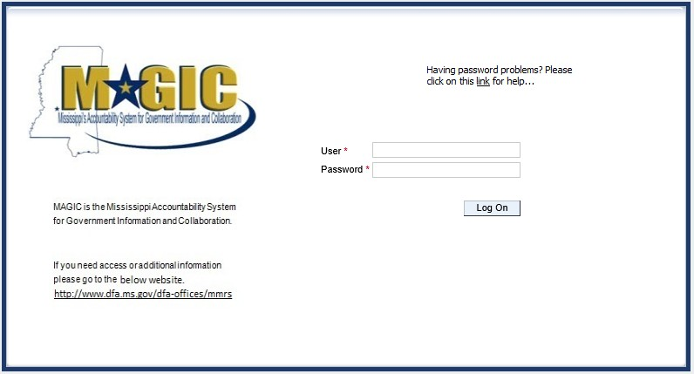

MAGIC Reverse Auction Bidders Guide

**View Available Reverse Auctions**

**Search for Auction(s)**

Listed below are the steps to search for a bid response.

1.) **Bidders must first respond to the RFx (RFQF) to be able to participate in the Reverse Auction.** Instructions for creating a response to an RFx are available here, [RFx Response -Supplier Self Service](https://sus.magic.ms.gov/sap/bc/webdynpro/sapsrm/wda_e_suco_sreg?originalContext=1.11.8507).

* The RFx (RFQF)– Bid Specifications will provide details for qualifying criteria. Only bidders qualified through the RFx (RFOF) will be invited to participate in Reverse Auctions.

2.) To search for auctions, click on the **Suppliers Self-Service** tab.

3.) Select **RFx and Auctions** in the navigation menu on the left of the screen. 4.) Select the **Published** link on the eAuctions line of the Active Queries section.

Note: If the search fields are not visible, click the  button to expand the search criteria.



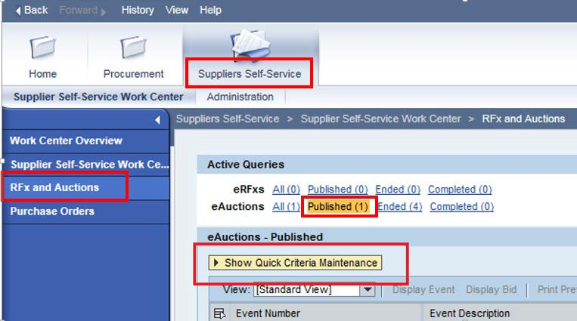

MAGIC Reverse Auction Bidders Guide

5.) Enter the search criteria. To find all available bid opportunities, skip to step (f).

1. Select **All** or **Published** to search for available Events (eAuctions).
2. Enter the appropriate *Quick Criteria Maintenance* fields: **Event Number** (Auction number) or complete any optional relevant search criteria.
3. Click on **Apply** to view all Auctions based on your search criteria.
4. To generate an updated search using the same selection criteria, click **Refresh**

or skip to step (7).

6.) Click **Apply** to find available bid opportunities.

7.) In the results list, click on the **Event Number** to open the Auction details in a separate window. (Pop-up blocker must be turned off.)



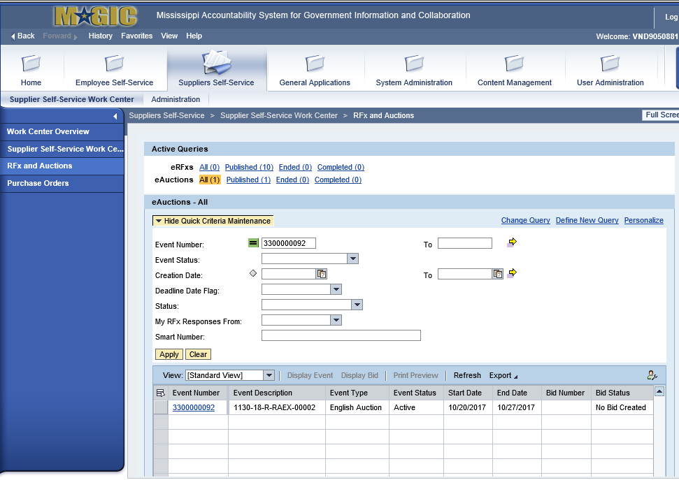

MAGIC Reverse Auction Bidders Guide

**Display Auction Details**

Listed below are the steps view the auction details and information regarding the auction. 1.) The Auction Details screen will be displayed. It is important to review the details prior

to the Auction begin time. Bidding will not be available prior to the Auction Start Date / Time.

The table below list the fields and a brief description of the information available on the Auction Parameters sub-tab of the Auction Information tab.



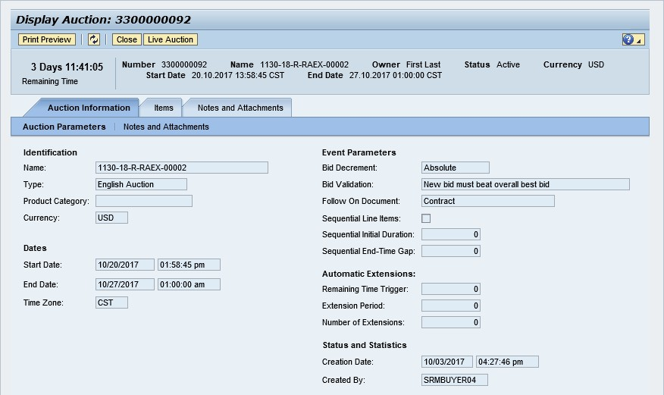

|  |  |  |
| --- | --- | --- |
| **Section** | **Field Name** | **Description** |
| Identification | Name | Smart Number with details related to the RFx |
| Type | English Auction is the standard for State of Mississippi |
| Product Category | The 5 digit NIGP code (optional) |
| Currency | US Dollar (USD) |
| Dates | Start Date | Begin Date and Time for the Live Auction |
| End Date | Date and Time of Live Auction completion |
| Time Zone | Central Standard Time (CST) |
| Event Parameters | Bid Decrement | The amount/percentage by which the next bid must decrease relevant to the current lowest bid. |
| Bid Validation | Logic used to determine if the bid is valid. |
| Follow On Document | Contract or Purchase Order |
| Sequential Line Items | Enables sequential line item functionality to stagger end times. |
| Sequential Initial Duration | The amount of time in between each line item end time. |
| Sequential End-Time Gap | The time between item end times. |
| Automatic | Remaining Time Trigger | The time period before the end of the auction where an |

MAGIC Reverse Auction Bidders Guide

|  |  |  |
| --- | --- | --- |
| Extensions |  | extension can be triggered due to bid activity. |
| Extension Period | Number of minutes, for which the auction will be extended if a bidder submits an offer within the Remaining Time Trigger period. |
| Number of Extensions | The number of times an auction can be extended by bid activity within the Remaining Time Trigger. |
| Status and Statistics | Creation Date | The date and time the auction was created. |
| Created By | The UserID of the Agency Buyer who created the auction. |

**Display Line Items**

Listed below is information regarding the line items associated with the auction. 1.) Click the **Items** tab to view the line items.

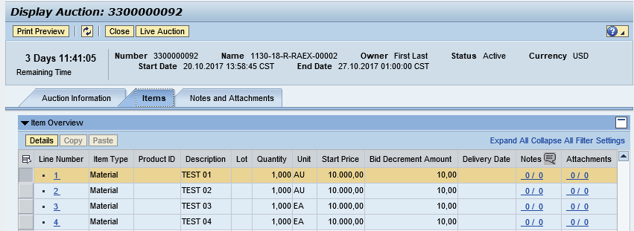

If the items are in **Lots**, the main items will be listed with individual lot items below.

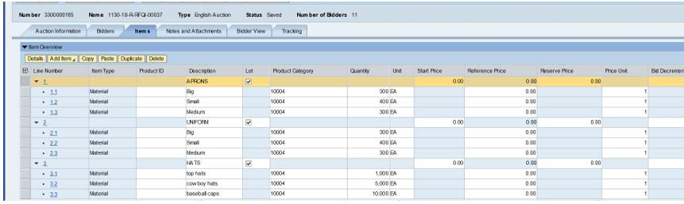

2.) To view additional details for a line item, select the desired line and click the  button.



MAGIC Reverse Auction Bidders Guide

3.) The details for the line item will be displayed.

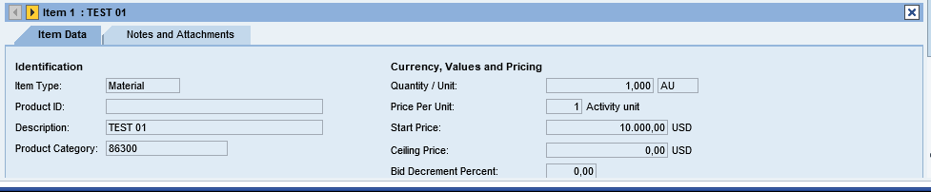

The table below list the fields and a brief description of the information available for each line item

|  |  |  |
| --- | --- | --- |
| **Section** | **Field Name** | **Description** |
| Identification | Item Name | Type of item (Material) |
| Product ID | 11 digit material number |
| Description | Detailed description of the item |
| Product Category | The 5 digit NIGP code |
| Currency, Values, and Pricing | Quantity /Unit | The number of items / the Unit of Measure (i.e. EA for each) |
| Price Per Unit | The individual price based on the Unit of Measure indicated. |
| Start Price | Starting bid price of the item (Bids higher than the start price will not be accepted.) |
| Ceiling Price | Ceiling Price is not used. |
| Bid Decrement Percent | Bid decrement amount if percentage option is selected. |
| Bid Decrement | Bid decrement amount if dollar amount option is selected. |



MAGIC Reverse Auction Bidders Guide

**Display Notes and Attachments**

Click the **Notes and Attachments** tab to view supporting documents and/or notes associated with the auction.

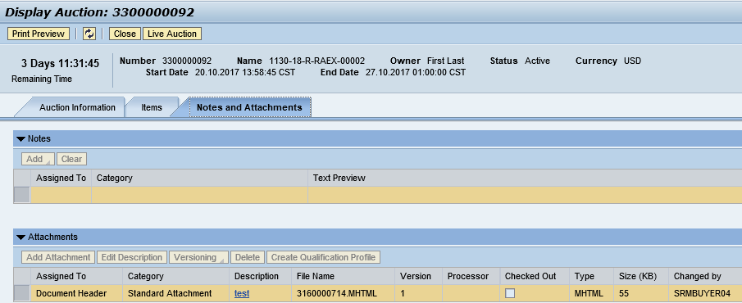

**Participating in a Live Auction**

After completing the steps above to find a desired auction, the steps below can be used to participate in the Live Auction process.

1.) With the Auction displayed, click the **Live Auction** button.

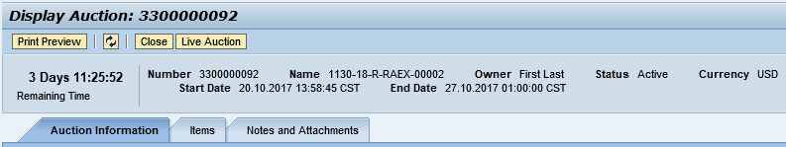

2.) A pop-up window will appear containing Terms and Conditions to participate in the Live Auction. Review all terms and conditions. If you agree, click **Accept**. If you click **Decline** you will not be allowed to participate in the Live Auction.

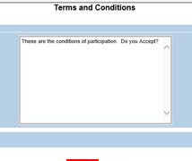

If the agency did not establishTerms and Conditions this screen will not be displayed.



MAGIC Reverse Auction Bidders Guide

3.) If any pop-ups appear asking for a confirmation to run the JAVA application, click **Run**.

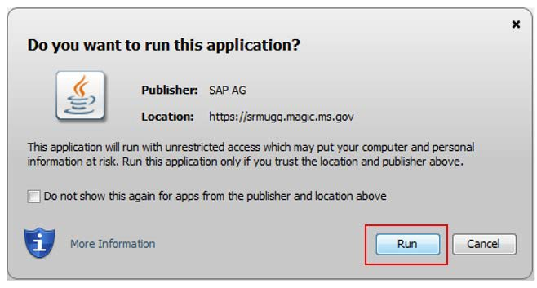

4.) The Live Auction bidding screen will be displayed. If you receive any error messages, please ask your company’s system administrator to verify your computer’s technical requirements.

**Live Auction Cockpit**

The Live Auction Cockpit will be displayed when the JAVA application has run.

Listed below is information regarding key items for the Live Auction Cockpit. The steps for submitting a response are located on the next page.

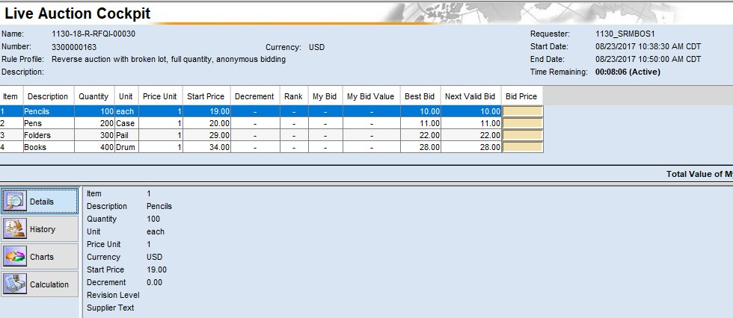

MAGIC Reverse Auction Bidders Guide

|  |  |
| --- | --- |
| **Field Name** | **Description** |
| Start Date | Date and Time the Live Auction starts |
| End Date | Date and Time the Live Auction ends |
| Time Remaining | The time remaining for the Live Auction |
| Description | Line item description |
| Quantity | Line item quantity |
| Unit | Line item unit |
| Price Unit | Line item price per unit |
| Start Price | The initial price for the line item. |
| Best Bid | The lowest bid that has been submitted, to date, for that line item. This field will be blank until the first bid has been submitted. |
| Next Valid Bid | The next price that is allowed to be bid for that line item. It is determined by subtracting the decrement amount from the best bid amount. |
| Bid Price | Your bid for the item. Your bid should be equal or less than the next valid bid field.  For instructions on how to enter your bid price, see the next page. |

**Submitting a Bid Response**

The steps below must be completed for each separate line item you wish to bid on.

1. Click desired line item.
2. Enter the price in the **Bid Price** field(s) for the items you wish to bid on.



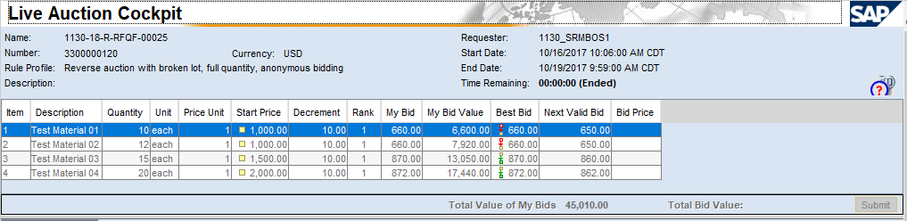

MAGIC Reverse Auction Bidders Guide

1. Click the **Submit** button. The submit button may be submitted after each line item price is entered or after you enter the price for all line items you wish to bid on.

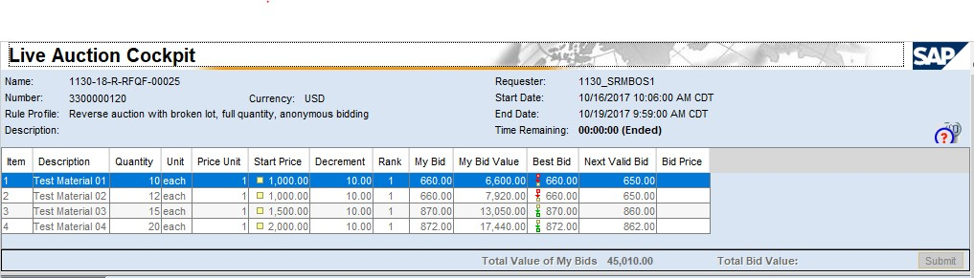

1. A confirmation pop-up window will be displayed. The bid value (by line item) will be display the total of the Unit Price times the Quantity for that item. If the bid amount(s) are correct, click **Yes**. If the bid amount(s) are incorrect, click **No** and repeat the steps above to enter the correct bid amounts.

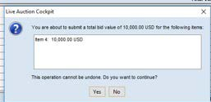

5.) A confirmation of a successful bid submission will be displayed in the Chat Window.

Note: Erroneous bids may be deleted by the agency during the live auction.

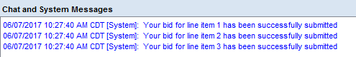

6.) Repeat steps 1 – 5 for each desired line item.





MAGIC Reverse Auction Bidders Guide

**Chat and System Messages**

The Chat and System Messages area is used for viewing chat messages from an agency buyer and information messages automatically generated by MAGIC.

Below are helpful hints in using the chat feature:

|  |  |
| --- | --- |
| **A bidder CAN:** | Send a message to an agency buyer.  Type the message in the message box and click **Send**. |
| See broadcast messages from the agency buyer to ALL bidders. |
| See messages regarding the status of the auction (e.g. paused, resumed, or extended) |
| **A bidder CANNOT:** | Send a message to other bidders of the auction. |
| See messages sent to an agency by other bidders. |
| See messages sent to other bidders from the agency buyer. |

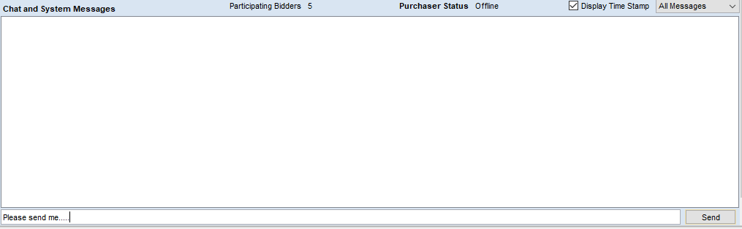

MAGIC Reverse Auction Bidders Guide

**Pausing and/or Resuming an Auction**

If necessary, the agency buyer can pause the Live Auction bidding. In such cases, the auction status will be changed from “Active” to “Paused”. A system alert will appear on the screen.

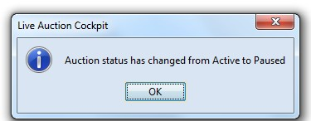

**The countdown clock will not stop running while the auction is paused. The time remaining and end date / time are not affected or extended automatically.**



When the agency buyer resumes the auction the auction status will be changed from “Paused” to “Active”. A system alert will appear on the screen.

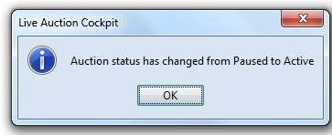

Once the auction has ended, a notification will display.

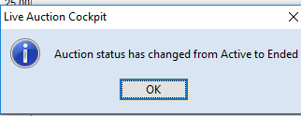

**Attachment A**

**Specifications for Reach Truck Fork Lift**

**Narrow Aisle Reach Truck**

**Compliance**

|  |  |  |
| --- | --- | --- |
| Yes_____ | No____ | Narrow Aisle Reach Truck Quantity: 2 |
| Yes____ | No____ | Base Capacity: 3,500 pounds |
| Yes____ | No____ | Net capacity with side shifter @270 inches: 2200 pounds (should meet or exceed) |
| Yes____ | No____ | Mast: 270” Maximum Fork Height |
| Yes____ | No____ | 119” Collapsed Height |
| Yes____ | No____ | 71” Free Lift |
| Yes____ | No____ | Tilt: 3 degrees forward, 4 degrees back |
| Yes____ | No____ | Voltage: 36 volts |
| Yes____ | No____ | Minimum aisle requirement: 9 feet (108 inches) |
| Yes____ | No____ | 34” ID/45” OD Outriggers |
| Yes____ | No____ | Easy access diagnostics |
| Yes____ | No____ | Multi-task controller |
| Yes____ | No____ | Power steering |
| Yes____ | No____ | Overhead guard |
| Yes____ | No____ | 48” load backrest |
| Yes____ | No____ | 42” forks |
| Yes____ | No____ | Battery compartment rollers |
| Yes____ | No____ | Side shifter w/hydraulics |
| Yes____ | No____ | Tilting fork carriage |
| Yes____ | No____ | Non-Keyed on/off switch |
| Yes____ | No____ | Horn |
| Yes____ | No____ | Emergency Power Disconnect |
| Yes____ | No____ | 350 amp battery connector |
| Yes____ | No____ | High speed lift cut out 12” from maximum lift (for safety) |
| Yes____ | No____ | Battery compartment size to accommodate an 18-125-13 battery |
| Yes____ | No____ | Battery size: 38 X 15 ¼ X 30 ½ inches |
| Yes____ | No____ | Sufficient battery must be included |

Maintenance must be provided by the vendor during the agreement period. Such maintenance shall include, but not limited to, tires and wheels as well as all other services provided under industry standards.

**Attachment B**

**Specifications for Stock Pickers**

**Compliance**

|  |  |  |
| --- | --- | --- |
| Yes_____ | No____ | Stock Picker Quantity: 4 |
| Yes____ | No____ | Base Capacity: 3,000 pounds |
| Yes____ | No____ | Net capacity @240 inches: 3,000 pounds (should meet or exceed) |
| Yes____ | No____ | Mast: 240” to 270” Maximum Fork Height |
| Yes____ | No____ | 107” to 119” Collapsed Height |
| Yes____ | No____ | 325” not to exceed 328” Extended height |
| Yes____ | No____ | Voltage: 24 volts |
| Yes____ | No____ | Minimum aisle requirement: 60” to 66” (5 feet to 5.5 feet) |
| Yes____ | No____ | Straddle width:42 inches (should not exceed) |
| Yes____ | No____ | Fork Length: 42 inches |
| Yes____ | No____ | Start up and run time diagnostics |
| Yes____ | No____ | Programmable performance features |
| Yes____ | No____ | Information Display Panel |
| Yes____ | No____ | Battery Discharge indicator with lift interrupt |
| Yes____ | No____ | Drive tire direction indicator |
| Yes____ | No____ | Hour meter |
| Yes____ | No____ | Battery compartment rollers |
| Yes____ | No____ | Side safety gates hinged or unhinged |
| Yes____ | No____ | Strobe Light |
| Yes____ | No____ | Non-Keyed on/off switch |
| Yes____ | No____ | Horn |
| Yes____ | No____ | Emergency Power Disconnect |
| Yes____ | No____ | 350 amp battery connector |
| Yes____ | No____ | Power Steering |
| Yes____ | No____ | Upper elevation travel |
| Yes____ | No____ | Pallet clamp |
| Yes____ | No____ | Battery compartment size to accommodate an 12-125-15 battery |
| Yes____ | No____ | Battery size: 38 X 12 – 14 max X 30 ½ inches |
| Yes____ | No____ | Sufficient battery must be included |

Maintenance must be provided by the vendor during the agreement period. Such maintenance shall include, but not limited to, tires and wheels as well as all other services provided under industry standards.

**Attachment C**

Revised Date: February 2017

1

RENTAL AGREEMENT

FOR USE BY MISSISSIPPI AGENCIES & GOVERNING AUTHORITIES AND VENDORS

(applicable to equipment rental transactions)

This Rental Agreement (hereinafter referred to as Agreement) is entered into by and between

**______________________________________________________________** (hereinafter referred to as Customer), and

**_** (hereinafter referred to as Vendor). This Agreement becomes effective upon signature by Customer and Vendor, and shall take precedence over all agreements and understandings between the parties. Vendor, by its acceptance hereof, agrees to rent to Customer, and Customer, by its acceptance hereof, agrees to rent from Vendor, the equipment, including applicable software and services to render it continually operational, listed in Exhibit A, which is attached hereto and incorporated herein.

1. CUSTOMER ACCOUNT ESTABLISHMENT:

* A separate Vendor Customer Number will be required for each specific customer/installation location.
* The Customer is identified as the entity on the first line of the "bill-to" address. All invoices and notices of changes will be sent to the "bill-to" address in accordance with Paragraph 8 herein.
* Ship-to and/or Installed-at address is the location to which the initial shipment of equipment/supplies will be made and the address to which service representatives will respond. Subsequent shipments of supplies for installed equipment will also be delivered to the "installed-at" address unless otherwise requested.
* Unless creditworthiness for this Customer Number has been previously established by Vendor, Vendor’s Credit Department may conduct a credit investigation for this Agreement. Notwithstanding delivery of equipment, Vendor may revoke this Agreement by written notice to the Customer if credit approval is denied within thirty (30) days after the date this Agreement is accepted for Vendor by an authorized representative.
* EQUIPMENT SELECTION, PRICES, AND AGREEMENT: The Customer has selected and Vendor agrees to provide the equipment, including applicable software and services to render it continually operational, identified on Exhibit A attached to this Agreement. The specific prices, inclusive of applicable transportation charges, are as set forth on the attached Exhibit A. The parties understand and agree that the Customer is exempt from the payment of taxes.
* SHIPPING AND TRANSPORTATION: Vendor agrees to pay all non-priority, ground shipping, transportation, rigging and drayage charges for the equipment from the equipment’s place of manufacture to the installation address of the equipment as specified under this Agreement. If any form of express shipping method is requested, it will be paid for by Customer.
* RISK OF LOSS OR DAMAGE TO EQUIPMENT: While in transit, Vendor shall assume and bear the entire risk of loss and damage to the equipment from any cause whatsoever. If, during the period the equipment is in Customer’s possession, due to gross negligence of the customer, the equipment is lost or damaged, then, the customer shall bear the cost of replacing or repairing said equipment.
* DELIVERY, INSTALLATION, ACCEPTANCE, AND RELOCATION:

A. DELIVERY: Vendor shall deliver the equipment to the location specified by Customer and pursuant to the delivery schedule agreed upon by the parties. If, through no fault of the Customer, Vendor is unable to deliver the equipment or software, the prices, terms and conditions will remain unchanged until delivery is made by Vendor. If, however, Vendor does not deliver the equipment or software within ten (10) working days of the delivery due date, Customer shall have the right to terminate the order without penalty, cost or expense to Customer of any kind whatsoever.

1. INSTALLATION SITE: At the time of delivery and during the period Vendor is responsible for maintenance of the equipment, the equipment installation site must conform to Vendor’s published space, electrical and environmental requirements; and the Customer agrees to provide, at no charge, reasonable access to the equipment and to a telephone for local or toll free calls.
2. INSTALLATION DATE: The installation date of the equipment shall be that date as is agreed upon by the parties, if Vendor is responsible for installing the equipment.
3. ACCEPTANCE: Unless otherwise agreed to by the parties, Vendor agrees that Customer shall have ten (10) working days from date of delivery and installation, to inspect, evaluate and test the equipment to confirm that it is in good working order.
4. RELOCATION: Customer may transfer equipment to a new location by notifying Vendor in writing of the transfer at least thirty (30) calendar days before the move is made. If Vendor is responsible for maintenance of the equipment, this notice will enable Vendor to provide technical assistance in the relocation efforts, if needed, as well as to update Vendor’s records as to machine location. There will be no cessation of rental charges during the period of any such transfer. The Vendor’s cost of moving and reinstalling equipment from one location to another is not included in this Agreement, and Customer agrees to pay Vendor, after receipt of invoice of Vendor’s charges with respect to such moving of equipment, which will be billed to Customer in accordance with Vendor’s standard practice then in effect for commercial users of similar equipment or software and payment remitted in accordance with Paragraph 8 herein.
5. RENTAL TERM: The rental term for each item of equipment shall be that as stated in the attached Exhibit A. If the Customer desires to continue renting the equipment at the expiration of the original rental agreement, the Customer must enter into a new rental agreement which shall be separate from this Agreement. There will be no automatic renewals allowed. There shall be no option to purchase.
6. OWNERSHIP: Unless the Customer has obtained title to the equipment, title to the equipment shall be and remain vested at all times in Vendor or its assignee and nothing in this Agreement shall give or convey to Customer any right, title or interest therein, unless purchased by Customer. Nameplates, stencils or other indicia of Vendor’s ownership affixed or to be affixed to the equipment shall not be removed or obliterated by Customer.
7. PAYMENTS:
8. INVOICING AND PAYMENTS: The charges for the equipment, software or services covered by this Agreement are specified in the attached Exhibit A. Charges for any partial month for any item of equipment shall be prorated based on a thirty (30) day month. Vendor shall submit an invoice with the appropriate documentation to Customer.
   * E-PAYMENT: The Vendor agrees to accept all payments in United States currency via the State of Mississippi’s electronic payment and remittance vehicle. The Customer agrees to make payment in accordance with Mississippi law on “Timely Payments for Purchases by Public Bodies”, Section 31-7-301, *et seq*. of the 1972 Mississippi Code Annotated, as amended, which generally provides for payment of undisputed amounts by the agency within forty-five (45) days of receipt of the invoice.
   * PAYMODE: Payments by state agencies using Mississippi’s Accountability System for Government Information and Collaboration (MAGIC) shall be made and remittance information provided electronically as directed by the State. The State, may at its sole discretion, require the Vendor to submit invoices and supporting documentation electronically at any time during the term of this Agreement. These payments shall be deposited into the bank account of the Vendor’s choice. The Vendor understands and agrees that the State is exempt from the payment of taxes. All payments shall be in United States currency**.**
9. METER READINGS: If applicable, the Customer shall provide accurate and timely meter readings at the end

of each applicable billing period on the forms or other alternative means specified by Vendor. Vendor shall have the right, upon reasonable prior notice to Customer, and during Customer’s regular business hours, to inspect the equipment and to monitor the meter readings. If Customer meter readings are not received in the time to be agreed upon by the parties, the meter readings may be obtained electronically or by other means or may be estimated by Vendor subject to reconciliation when the correct meter reading is received by Vendor.

C. COPY CREDITS: If applicable, if a copier is being rented, the Customer will receive one (1) copy credit for each copy presented to Vendor which, in the Customer’s opinion, is unusable and also for each copy which was produced during servicing of the equipment. Copy credits will be issued only if Vendor is responsible for providing equipment services or maintenance services (except time and materials maintenance). Copy credits will be reflected on the invoice as a reduction in the total copy volume, except for run length plans which will be credited at a specific copy credit rate as shown on the applicable price list.

1. USE OF EQUIPMENT: Customer shall operate the equipment according to the manufacturer’s specifications and documented instructions. Customer agrees not to employ or use additional attachments, features or devices on the equipment or make changes or alterations to the equipment covered hereby without the prior written consent of Vendor in each case, which consent shall not be unreasonably withheld.
2. MAINTENANCE SERVICES, EXCLUSIONS, AND REMEDIES:
3. SERVICES: If Vendor is responsible for providing equipment services, maintenance services (except for time and materials), or warranty services: (1) Vendor shall install and maintain the equipment and make all necessary adjustments and repairs to keep the equipment in good working order. (2) Parts required for repair may be used or reprocessed in accordance with Vendor’s specifications and replaced parts are the property of Vendor, unless otherwise specifically provided on the price lists. (3) Services will be provided during Customer’s usual business hours. (4) If applicable, Customer will permit Vendor to install, at no cost to Customer, all retrofits designated by Vendor as mandatory or which are designed to insure accuracy of meters.
4. EXCLUSIONS: The following is not within the scope of services: (1) Provision and installation of optional retrofits. (2) Services connected with equipment relocation. (3) Installation/removal of accessories, attachments or other devices. (4) Exterior painting or refinishing of equipment. (5) Maintenance, installation or removal of equipment or devices not provided by Vendor. (6) Performance of normal operator functions as described in applicable Vendor operator manuals. (7) Performance of services necessitated by accident; power failure; unauthorized alteration of equipment or software; tampering; service by someone other than Vendor; causes other than ordinary use; interconnection of equipment by electrical, or electronic or mechanical means with noncompatible equipment, or failure to use operating system software. If Vendor provides, at the request of the Customer, any of the services noted above, the Customer may be billed by Vendor at a rate not to exceed the Master State Prices Agreement between the Vendor and the State of Mississippi, or in the absence of such agreement at the then current time and materials rates.
5. REMEDIES: If during the period in which Vendor is providing maintenance services, Vendor is unable to maintain the equipment in good working order, Vendor will, at no additional charge, provide either an identical replacement or another product that provides equal or greater capabilities.

11. HOLD HARMLESS: To the fullest extent allowed by law, Vendor shall indemnify, defend, save and hold harmless, protect, and exonerate the Customer and the State of Mississippi, its Commissioners, Board Members, officers, employees, agents, and representatives from and against all claims, demands, liabilities, suits, actions, damages, losses, and costs of every kind and nature whatsoever, including, without limitation, court costs, investigative fees and expenses, and attorneys’ fees, arising out of or caused by Vendor and/or its partners, principals, agents, employees, and/or subcontractors in the performance of or failure to perform this Agreement. In the Customer’s sole discretion, Vendor may be allowed to control the defense of any such claim, suit, etc. In the event Vendor defends said claim, suit, etc., Vendor shall use legal counsel acceptable to the Customer; Vendor shall be solely liable for all reasonable costs and/or expenses associated with such defense and the Customer shall be entitled to participate in said defense. Vendor shall not settle any claim, suit, etc., without the Customer’s concurrence, which the Customer shall not unreasonably withhold.

12. ALTERATIONS, ATTACHMENTS, AND SUPPLIES:

1. If Customer makes an alteration, attaches a device or utilizes a supply item that increases the cost of services, Vendor will either propose an additional service charge or request that the equipment be returned to its standard configuration or that use of the supply item be discontinued. If, within five (5) days of such proposal or request, Customer does not remedy the problem or agree in writing to do so within a reasonable amount of time, Vendor shall have the right to terminate this Agreement as provided herein. If Vendor believes that an alteration, attachment or supply item affects the safety of Vendor personnel or equipment users, Vendor shall notify Customer of the problem and may withhold maintenance until the problem is remedied.
2. Unless Customer has obtained title to the equipment free and clear of any Vendor security interest, Customer may not remove any ownership identification tags on the equipment or allow the equipment to become fixtures to real property.
3. ASSIGNMENT: The Vendor shall not assign, subcontract or otherwise transfer in whole or in part, its right or obligations under this Agreement without prior written consent of the Customer. Any attempted assignment or transfer without said consent shall be void and of no effect.
4. GOVERNING LAW: This Agreement shall be governed by and construed in accordance with the laws of the State of Mississippi, excluding its conflicts of laws provisions, and any litigation with respect thereto shall be brought in the courts of said state. The Vendor shall comply with applicable federal, state, and local laws and regulations.
5. NOTICE: Any notice required or permitted to be given under this Agreement shall be in writing and personally delivered or sent by certified United States mail, postage prepaid, return receipt requested, to the party to whom the notice should be given at the address set forth below. Notice shall be deemed given when actually received or when refused. The parties agree to promptly notify each other in writing of any change of address.

**For the Vendor: For the Customer:**

Name Name

Title Title

Address Address

City, State, & Zip Code City, State, & Zip Code

1. WAIVER: Failure by the Customer at any time to enforce the provisions of this Agreement shall not be construed as a waiver of any such provisions. Such failure to enforce shall not affect the validity of this Agreement or any part thereof or the right of the Customer to enforce any provision at any time in accordance with its terms.
2. CAPTIONS: The captions or headings in this Agreement are for convenience only, and in no way define, limit or describe the scope or intent of any provision or section of this Agreement.
3. SEVERABILITY: If any term or provision of this Agreement is prohibited by the laws of the State of Mississippi or declared invalid or void by a court of competent jurisdiction, the remainder of this Agreement shall be valid and enforceable to the fullest extent permitted by law.
4. THIRD PARTY ACTION NOTIFICATION: Vendor shall give Customer prompt notice in writing of any action or suit filed, and prompt notice of any claim made against Vendor by any entity that may result in litigation related in any way to this Agreement.
5. AUTHORITY TO CONTRACT: Vendor warrants that it is a validly organized business with valid authority to enter into this Agreement and that entry into and performance under this Agreement is not restricted or prohibited by any loan,

security, financing, contractual or other agreement of any kind, and notwithstanding any other provision of this Agreement to the contrary, that there are no existing legal proceedings, or prospective legal proceedings, either voluntary or otherwise, which may adversely affect its ability to perform its obligations under this Agreement.

1. RECORD RETENTION AND ACCESS TO RECORDS: The Vendor agrees that the Customer or any of its duly authorized representatives at any time during the term of this Agreement shall have unimpeded, prompt access to and the right to audit and examine any pertinent books, documents, papers, and records of the Vendor related to the Vendor’s charges and performance under this Agreement. All records related to this Agreement shall be kept by the Vendor for a period of three (3) years after final payment under this Agreement and all pending matters are closed unless the Customer authorizes their earlier disposition. However, if any litigation, claim, negotiation, audit or other action arising out of or related in any way to this Agreement has been started before the expiration of the three (3) year period, the records shall be retained for one (1) year after all issues arising out of the action are finally resolved. The Vendor agrees to refund to the Customer any overpayment disclosed by any such audit arising out of or related in any way to this Agreement.
2. EXTRAORDINARY CIRCUMSTANCES: If either party is rendered unable, wholly or in part, by reason of strikes, accidents, acts of God, weather conditions or any other acts beyond its control and without its fault or negligence to comply with any obligations or performance required under this Agreement, then such party shall have the option to suspend its obligations or performance hereunder until the extraordinary performance circumstances are resolved. If the extraordinary performance circumstances are not resolved within a reasonable period of time, however, the non-defaulting party shall have the option, upon prior written notice, of terminating the Agreement.
3. TERMINATION: This Agreement may be terminated as follows: (a) Customer and Vendor mutually agree to the termination, or (b) If either party fails to comply with the terms and conditions of this Agreement and that breach continues for thirty (30) days after the defaulting party receives written notice from the other party, then the non-defaulting party has the right to terminate this Agreement. The non-defaulting party may also pursue any remedy available to it in law or in equity. Upon termination, all obligations of Customer to make payments required hereunder shall cease.
4. AVAILABILITY OF FUNDS: It is expressly understood and agreed that the obligation of the Customer to proceed under this Agreement is conditioned upon the appropriation of funds by the Mississippi State Legislature and the receipt of state and/or federal funds. If the funds anticipated for the continuing fulfillment of the agreement are, at any time, not forthcoming or insufficient, either through the failure of the federal government to provide funds or of the State of Mississippi to appropriate funds or the discontinuance or material alteration of the program under which funds were provided or if funds are not otherwise available to the Customer, the Customer shall have the right upon ten (10) working days written notice to the Vendor, to terminate this Agreement without damage, penalty, cost or expenses to the Customer of any kind whatsoever. The effective date of termination shall be as specified in the notice of termination.
5. MODIFICATION OR RENEGOTIATION: This Agreement may be modified, altered or changed only by written agreement signed by the parties hereto. The parties agree to renegotiate the Agreement if federal, state and/or the Customer’s revisions of any applicable laws or regulations make changes in this Agreement necessary.
6. WARRANTIES: Vendor warrants that the equipment, when operated according to the manufacturer’s specifications and documented instructions, shall perform the functions indicated by the specifications and documented literature. Vendor may be held liable for any damages caused by failure of the equipment to function according to specifications and documented literature published by the manufacturer of the equipment.
7. E-VERIFY COMPLIANCE: If applicable, the Vendor represents and warrants that it will ensure its compliance with the Mississippi Employment Protection Act of 2008, Section 71-11-1, *et seq*. of the Mississippi Code Annotated (Supp 2008), and will register and participate in the status verification system for all newly hired employees. The term “employee” as used herein means any person that is hired to perform work within the State of Mississippi. As used herein, “status verification system” means the Illegal Immigration Reform and Immigration Responsibility Act of 1996 that is operated by the United States Department of Homeland Security, also known as the E-Verify Program, or any other successor electronic verification system replacing the E-Verify Program. The Vendor agrees to maintain records of such compliance and, upon request of the State and

approval of the Social Security Administration or Department of Homeland Security, where required, to provide a copy of each such verification to the Customer. The Vendor further represents and warrants that any person assigned to perform services hereafter meets the employment eligibility requirements of all immigration laws of these warranties, the breach of which may subject the Vendor to the following: (1) termination of this Agreement and ineligibility for any state or public contract in Mississippi for up to three (3) years, with notice of such cancellation/termination being made public, or (2) the loss of any license, permit, certification or other document granted to the Vendor by an agency, department or governmental entity for the right to do business in Mississippi for up to one (1) year, or (3) both --in the event of such cancellation/termination, the Vendor would also be liable for any additional costs incurred by the Customer due to the contract cancellation or loss of license or permit.

1. HARD DRIVE SECURITY: Vendor must properly format the hard drive, deleting all information, or replace the hard drive with a new hard drive prior to storing or re-selling the equipment. The Customer may request to retain the hard drive for a nominal fee. Vendor will supply written notification to the Customer that all data has been made inaccessible. This notification must be provided with forty-five (45) days of the equipment being returned to the Vendor.
2. ENTIRE AGREEMENT: This Agreement constitutes the entire agreement of the parties with respect to the equipment, software or services described herein and supersedes and replaces any and all prior negotiations, understandings and agreements, written or oral, between the parties relating hereto. No terms, conditions, understandings, usages of the trade, course of dealings or agreements, not specifically set out in this Agreement or incorporated herein, shall be effective or relevant to modify, vary, explain or supplement this Agreement.
3. TRANSPARENCY: This Agreement, including any accompanying exhibits, attachments, and appendices, is subject to the “Mississippi Public Records Act of 1983,” codified as Section 25-61-1 et seq., Mississippi Code Annotated and exceptions found in Section 79-23-1 of the Mississippi Code Annotated (1972, as amended). In addition, this Agreement is subject to provisions of the Mississippi Accountability and Transparency Act of 2008 (MATA), codified as Section 27-104-151 of the Mississippi Code Annotated (1972, as amended). Unless exempted from disclosure due to a court-issued protective order, this Agreement is required to be posted to the Department of Finance and Administration’s independent agency contract website for public access. Prior to posting the Agreement to the website, any information identified by the Vendor as trade secrets, or other proprietary information including confidential vendor information, or any other information which is required confidential by state or federal law or outside the applicable freedom of information statutes will be redacted. A fully executed copy of this Agreement shall be posted to the State of Mississippi’s accountability website at: [http://www.transparency.mississippi.gov.](http://www.transparency.mississippi.gov/)

31. COMPLIANCE WITH LAWS: The Vendor understands that the Customer is an equal opportunity employer and therefore maintains a policy which prohibits unlawful discrimination based on race, color, creed, sex, age, national origin, physical handicap, disability, genetic information, or any other consideration made unlawful by federal, state, or local laws. All such discrimination is unlawful and the Vendor agrees during the term of the Agreement that the Vendor will strictly adhere to this policy in its employment practices and provision of services. The Vendor shall comply with, and all activities under this Agreement shall be subject to, all applicable federal, State of Mississippi, and local laws and regulations, as now existing and as may be amended or modified.

Revised Date: February 2017

For the faithful performance of the terms of this Agreement, the parties have caused this Agreement to be executed by their undersigned representatives.

Witness my signature this the_______________________ day of______________________ 20_______.

Vendor: _____________________________________________

By:_________________________________________________

Authorized Signature

Printed Name:_________________________________ Title:________________________________________

WITNESS:

____________________________________________________

____________________________________________________

Witness my signature this the_______________________ day of____________________ , 20________ .

Customer: __________________________________________

By:________________________________________________

Authorized Signature

Printed Name: **_________________________________**

Title: _________________________________________

WITNESS:

_________________________________

________________________________

Revised Date: February 2017

EXHIBIT A

RENTAL AGREEMENT FOR USE BY

MISSISSIPPI Agencies AND VENDORS

(Applicable to Equipment Rental Transactions)

The following, when signed by the Customer and the Vendor shall be considered to be a part of the Rental Agreement between the parties.

State Contract Number:________________________________________________

Vendor Company Name:________________________________________________________

Customer Agency Name:________________________________________________

Bill to Address:________________________________________________________

Ship to Address:

Description of Equipment, Software, or Services Price

Delivery Schedule and Installation Date:

Rental Term: (Number of Months)

Start Date:

End Date:

Modifications:__________________________________________________________________

______________________ _____________________

Vendor Signature Customer Signature

**Bid Cover Sheet**

**NAME OF COMPANY __________________________________________________**

**QUOTED BY ___________________________________________________________**

**SIGNATURE____________________________________________________________**

**ADDRESS______________________________________________________________**

**CITY/STATE/ZIP_______________________________________________________**

**TELEPHONE ___________________________________________________________**

**FAX NUMBER__________________________________________________________**

**EMAIL ADDRESS_______________________________________________________**

**NAME AND PHONE NUMBER OF COMPANY REPRESENTATIVE TO BE CONTACTED BY AGENCY SEEKING TO CONTRACT FOR SERVICES PURSUANT TO THIS IFB**

**________________________________________________________________________**

**In addition to providing the above contact information, please answer the following question regarding your company:**

What year was your company started? ________________________________________

**Certification**

By signing below, the company representative certifies that he/she has authority to bind the company, and further acknowledges and certifies on behalf of the company:

1. That he/she has thoroughly read and understands the terms and conditions, instructions and specifications for the Invitation for Bid and Attachments.
2. The company meets all requirements and acknowledges all certifications contained in the IFB and Attachments.
3. The company agrees to all provisions of the IFB and Attachments
4. The company will perform the services required at the prices quoted on the bid form.
5. The company represents that it has not retained a person to solicit or secure a State contract upon an agreement or understanding for a commission, percentage, brokerage, or contingent fee, except as disclosed in the contractor’s bid or proposal.
6. That, to the best of its knowledge and belief, the cost or pricing data submitted is accurate, complete and current as of the submission date.
7. That the company has, or will secure, at its own expense, applicable personnel who shall be qualified to perform the duties required to be performed under this Invitation for Bid.

*[Please execute and return with Bid Materials.]*

Company:_____________________________ Signature__________________________

Date:_________________________________ Title:_____________________________

Printed Name:_____________________________

**Bid Form**

Bid Number**:** #

Gentlemen:

Pursuant to the advertisement for bids to be received, I/We _______________________

____________________________located at __________________________________

do submit our bid form for Bid #________________. This bid is made without collusion

on the part of any person, firm or corporation.

**Reach Truck (2)__________________________________**

**Stock Pickers (4)__________________________________**

**Total Bid _______________________________________**

Exceptions and/or Deviations? Yes___ No___

If “Yes”, please list on an accompanying document.

**BID#:**

………………………………………………………………………………………………

Company:___________________________ Signature:_____________________

Address:____________________________ Printed name:__________________

____________________________ Title:_________________________

Phone:______________________________ Date:_________________________

E-mail Address_______________________

**References**

**REFERENCE #1**

Name of Company:

Contact Person:

Address:

City/State/Zip:

Telephone Number:

Cell Number:

E-mail:

Alternative Contact Person (optional):

Telephone Number:

Cell Number:

E-mail:

**REFERENCE #2**

Name of Company:

Contact Person:

Address:

City/State/Zip:

Telephone Number:

Cell Number:

E-mail:

Alternative Contact Person (optional):

Telephone Number:

Cell Number:

E-mail:

**REFERENCE #3**

Name of Company:

Contact Person:

Addres:

City/State/Zip:

Telephone Number:

Cell Number:

E-mail:

Alternative Contact Person (optional):

Telephone Number:

Cell Number:

E-mail:

**REFERENCE #4**

Name of Company:

Contact Person:

Address:

City/State/Zip:

Telephone Number:

Cell Number:

E-mail:

Alternative Contact Person (optional):

Telephone Number:

Cell Number:

E-mail:

**REFERENCE #5**

Name of Company:

Contact Person:

Address:

City/State/Zip:

Telephone Number:

Cell Number:

E-mail:

Alternative Contact Person (optional):

Telephone Number:

Cell Number:

E-mail:

**REFERENCE #6**

Name of Company:

Contact Person:

Address:

City/State/Zip:

Telephone Number:

Cell Number:

E-mail:

Alternative Contact Person (optional):

Telephone Number:

Cell Number:

E-mail:

**Acknowledgement of Amendments**

I hereby acknowledge receipt of the following amendments and understand that such amendments are incorporated into the Bid Packet and will become a part of any resulting contract.

List date and title/number of all amendments: (Write “None” if applicable)

1.________________________________________________________________

2.________________________________________________________________

3.________________________________________________________________

4.________________________________________________________________

5.________________________________________________________________

_______________________________________

Signature

_______________________________________

Printed Name

_______________________________________

Title

________________________________________

Date

**Secretary of State Acknowledgement**

______________________________________, acknowledges that we

(Vendor Name)

________ are registered with the Secretary of State’s Office.

(Attach proof)

________ are not registered with the Secretary of State’s Office.

We, ______________________________________________

(Vendor Name)

_______ will register before the start of the contract and provide proof.

_______ will not register.

__________________________________________ _________

Signature Date

___________________________________________

Printed Name